**ASSIGNMENT-4**

Create email newsletter design using Mailchimp or Canva tool

|  |  |
| --- | --- |
| NAME | S.SATHISH |
| NM ID | D3AB4E60998F2BBA802428A0FF7D9B00 |
| ASSIGNMENT 4 | Create email newsletter design using Mailchimp or Canva tool |

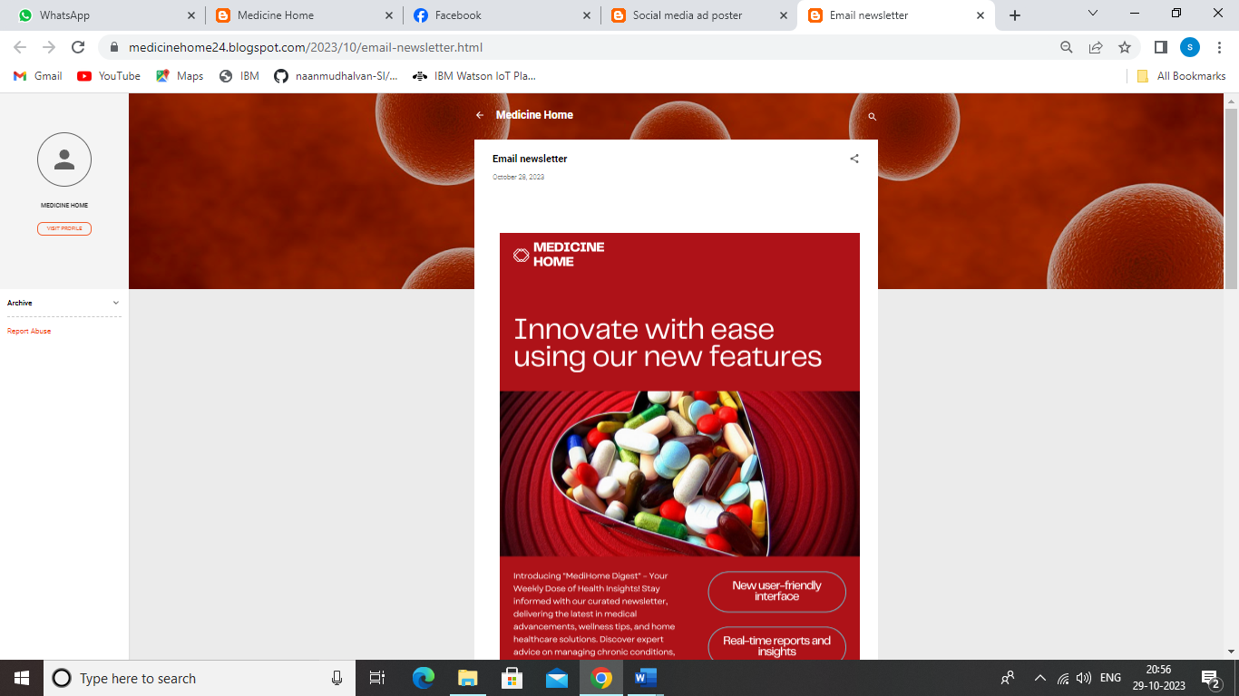

**CANVA EMAIL NEWSLETTER LINK:**

[**https://medicinehome24.blogspot.com/2023/10/email-newsletter.html**](https://medicinehome24.blogspot.com/2023/10/email-newsletter.html)